**Get Puk’d – AI Component**

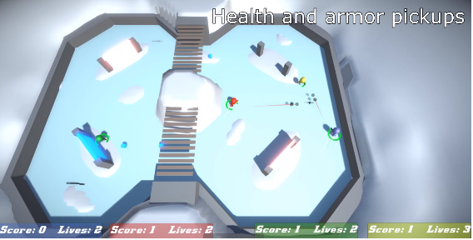The game that I am adding an AI component to is called *Get Puk’d*, which is a couch multiplayer shooter set in an ice rink. The main features of the game are using your gun to propel yourself around the map faster. Physics is a big part of the game.

The AI that I am going to implement is the other characters in the game which will add a story mode element to the game.

The main functions that these AI will have is to search for the other players, decide who they are going after in that confrontation, decide whether to pick up a new weapon or go with what they currently have equipped. Then to shoot at the character that they have selected in that confrontation or to hide behind cover as other characters are in the way.

The story of the game is that Americas president *David Stump* has risen up and taken over Canada and captured its citizens and the only way for them to earn their freedom, is to fight in a series of death matches with other participants until they have made enough money for their sponsor who will then release them.

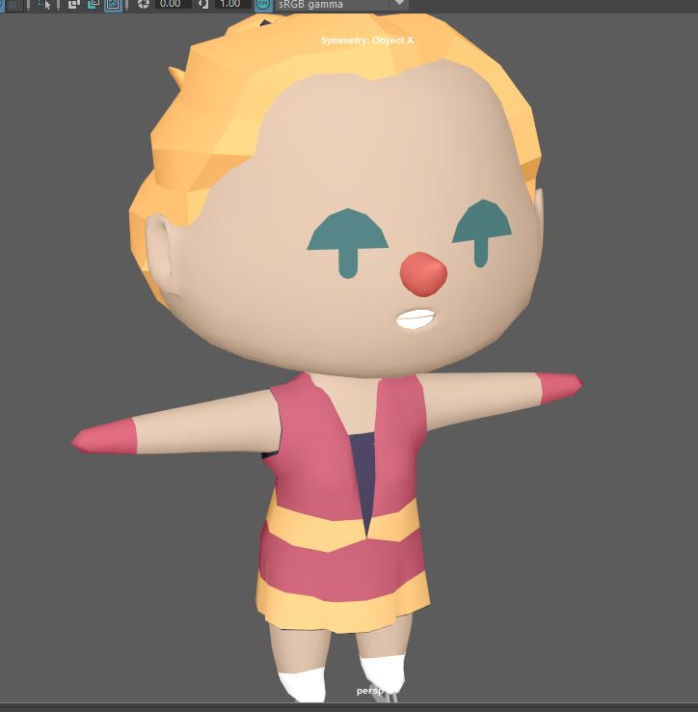I wanted to give the characters separate personality’s such as the Hockey Player having a rivalry with the Speed Skater (names will be given), this would add some variety to the gameplay, as the player character could then target other CPU controlled characters if they realise that one character is always aiming for another character more than others.

A similar mechanic to this is the ghosts from Pac-Man that have their own way of moving, I would have the AI characters move in a similar way to this, but also try not to make them too predictable so only have the personality of a character have a 25% chance activating otherwise they will revert to the default personality. This will hopefully mean the game does not become stale, I could also add a difficulty setting of Easy, Medium and Hard to the story mode as a way of upping the challenge.

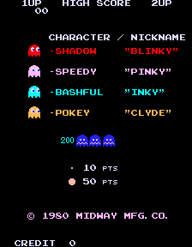The way that I intend to have the characters move as I want them to is by using **Vectors** to control where the characters should move compared to others on the map and using **Tags** to decide which character the AI should move after if their personality has been activated for that round and similar to Pac-Mans ghosts decide whether they will target in front or behind the character they have decided to attack. I feel that this will make them slightly more realistic/ similar to real players.

In terms of scope I have already implemented the basics of the component such as moving towards the character and picking which character it wants to attack. The real challenge will be having to make it decide where and how it is going to attack or hide. I think I may do this using a weighting system, such as some actions having a priority of 1 meaning they are most important and some other actions having a weighting of 10 which would mean they are not as an important.